# **PRODUCT DESIGN**

State vocational and technical education board system design is comprised of several diagrams that give information about the design of the system. These include:

1. UML class diagram.
2. UML use Case diagram.
3. UML sequence diagram.
4. Database design diagram.

The following sections elaborate these concepts

## **UML CLASS DIAGRAM**

The UML (Unified Modelling Language) class diagram is as shown in the figure below.



*A diagram showing the class diagram for state vocational and technical education system*

As shown from the diagram above, the classes for the system are as elaborated below:

The school class consists the following member variables: Name (text), Location (text), Capacity (number) and Other Details (text).

The student class consists of the following member variables: Student No (text), Name (text), Personal Id (text), Gender (text), Other details (text), Course (Course) and School (School). Every student is assigned a course upon registration and every student belongs to a school.

The user class consists of the following member variables: User Name (text), Password (text), Other details (text) and School (School). Every user belongs to a school.

The course class consists of the following member variables: Course Name (text),

Other details (text) and School (School). Every course belongs to a school.

The alumni class consists of the following member variables: First name (text), Last name (text), Other details (text), Student (Student). Every school alumni were once a student.

The extra curriculum class consists of the following member variables: Name (text), Other details (text), School (School). Every extra curriculum activity belongs to a school.

The training equipment class consists of the following member variables: Name (text), Cost (float), Other details (text), School (School). Every training equipment is assigned to a school.

The facility class consists of the following member variables: Name (text), Type (text), Capacity (float), Other details (text), Status (number) and School (School). Every facility belongs to a school.

The university affiliation class consists of the following member variables: University Name (text), Other details (text), School (School). Every university affiliation is associated to a school.

The fund disbursement class consists of the following member variables: Fund name (text), Amount (float), Other Details (text) and School (School). Funds are disbursed to schools.

## **UML USE CASE DIAGRAM**

## This diagram is used to give the details about the functions in which the various system users can perform in the state vocational and technical education board. This diagram is as shown below:

## 

*A diagram of the use case diagram for state vocational and technical education system*

From the diagram above, a school administrator can perform the following functions: Manage students, manage student attendance, manage student discipline, manage exams, manage exam results, manage extra curriculum activities, manage funds usage, manage student leaving records, and manage school affiliations.

The state vocational and technical education board administrator can perform the following functions: manage schools, manage users, manage facilities, manage training equipment, manage courses, disburse funds and view reports.

## **UML SEQUENCE DIAGRAM**

The following is a sample use case diagram for a school administrator accessing the state vocational and technical education board.



*A diagram of a sample sequence diagram for state vocational and technical education system*

As shown from the diagram above, the user enters their username and password into the system. The system validates the username and password passing the result of this validation to the user on the user interface. In case the entered credentials are not valid, the user is prompted to re-enter these details. In case the entered credentials are valid, a student details entry form is displayed for the user to register a student.

The user then enters the student details and then submits the form for processing by the server. The server then validates these entered details and passes the results of this validation to the user on the user interface. In case the entered details are invalid, the user is prompted to re-enter the details. If the entered details are valid, the user is prompted to confirm the transaction. In case the user confirms the transaction, the same is performed in the server and an empty student details form is displayed with the message on the status of the transaction.

## **DATABASE DESIGN DIAGRAM**

The following is the database design diagram for the state vocational and technical education board.

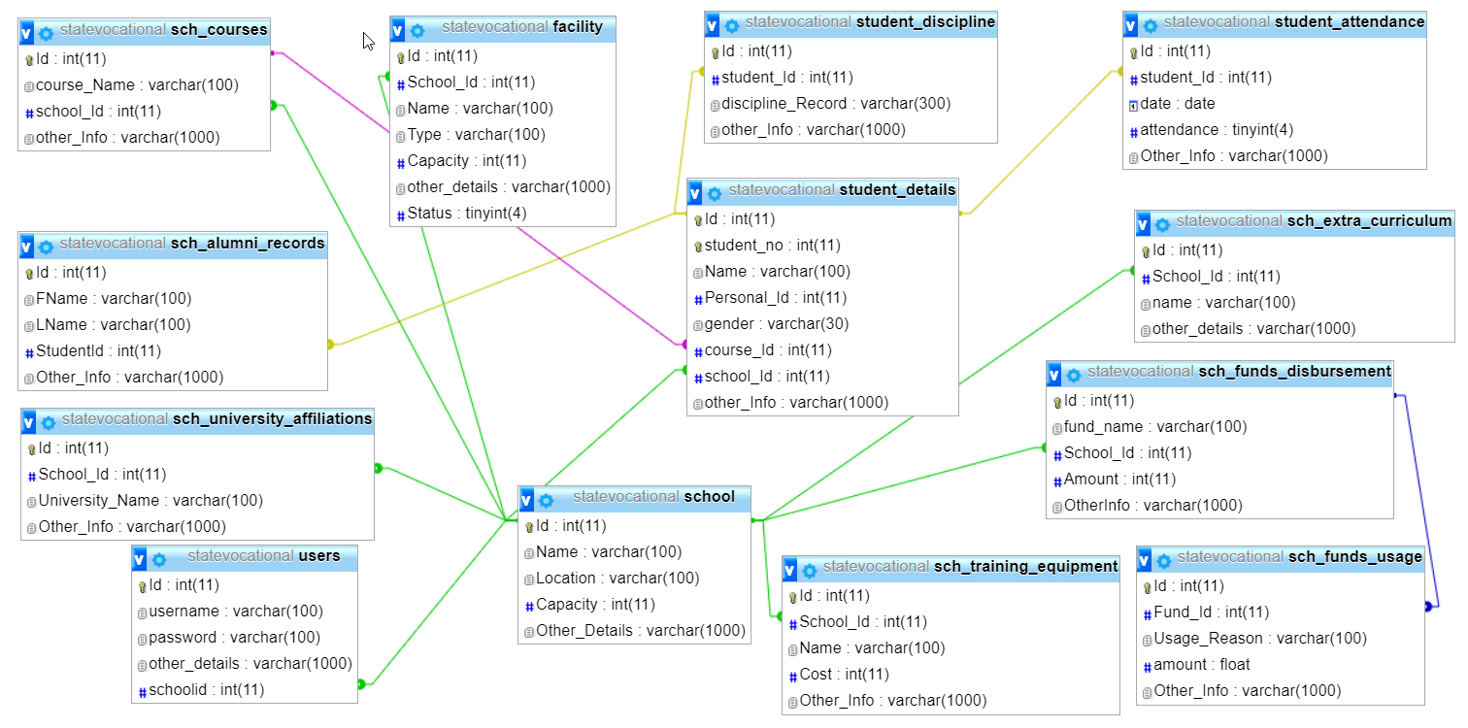*A diagram of the database diagram for state vocational and technical education system*

The database design diagram can be described below:

The school table consist of the columns: Id, name, location, capacity, and other_details. The primary key for the table is id. The name column is a unique column in the table.

The student_details table consists of the following columns: Id, student_no, Name, Personal_Id, gender, course_Id, school_Id and other_Info. The primary key for the table is Id. The columns course_Id and school_Id are foreign keys representing tables Courses and School respectively.

The users table consists of the following columns: id, username, password, other_details and schoolid. The primary key for the table is Id. The column schoolid is a foreign key representing table school.

The sch_courses table consists of the following columns: Id, course_Name, school_Id and other_Info. The primary key for the table is Id. The column school_Id is a foreign key representing table school.

The sch_extra_curriculum table consists of the following columns: Id, name, other_details and School_Id. The primary key for the table is Id. The column School_Id is a foreign key representing table school.

The sch_training_equipment table consists of the following columns: Id, Name, Cost, Other_info and School_Id. The primary key for table is Id. The column School_Id is a foreign key representing table School.

The facility table consists of the following columns: Id, Name, Type, Capacity, Other_details, Status and School_Id. The primary key for table is Id. The column School_Id is a foreign key representing table School.

The sch_university_affiliation table consists of the following columns: Id, university_Name, Other_details and School_Id. The primary key for table is Id. The column School_Id is a foreign key representing table School.

The sch_funds_disbursement table consists of the following columns: Id, fund_Name, Amount, OtherInfo and School_Id. The primary key for table is Id. The column School_Id is a foreign key representing table School.

The sch_funds_usage table consists of the following columns: Id, Fund_Id, usage_reason, amount and Other_Info. The primary key for table is Id. The column Fund_Id is a foreign key representing table sch_funds_disbursement.

The sch_alumni_records table consists of the following columns: Id, FName, LName, StudentId, and Other_Info. The primary key for table is Id. The column StudentId is a foreign key representing table student_details.

The student_attendance table consists of the following columns: Id, student_Id, date, attendance and Other_Info. The primary key for table is Id. The column student_Id is a foreign key representing table student_details.

# **PRODUCT IMPLEMENTATION**

The state vocational and technical education board system was implemented using several technologies. The system sits on a MySQL database. An apache web service exists that processes page requests between the user interface and the database. HTML (Hypertext Markup Language) is used in designing the system forms. PHP language is the scripting language that is used in programming the system.

The functionalities implemented in the system are as described below:

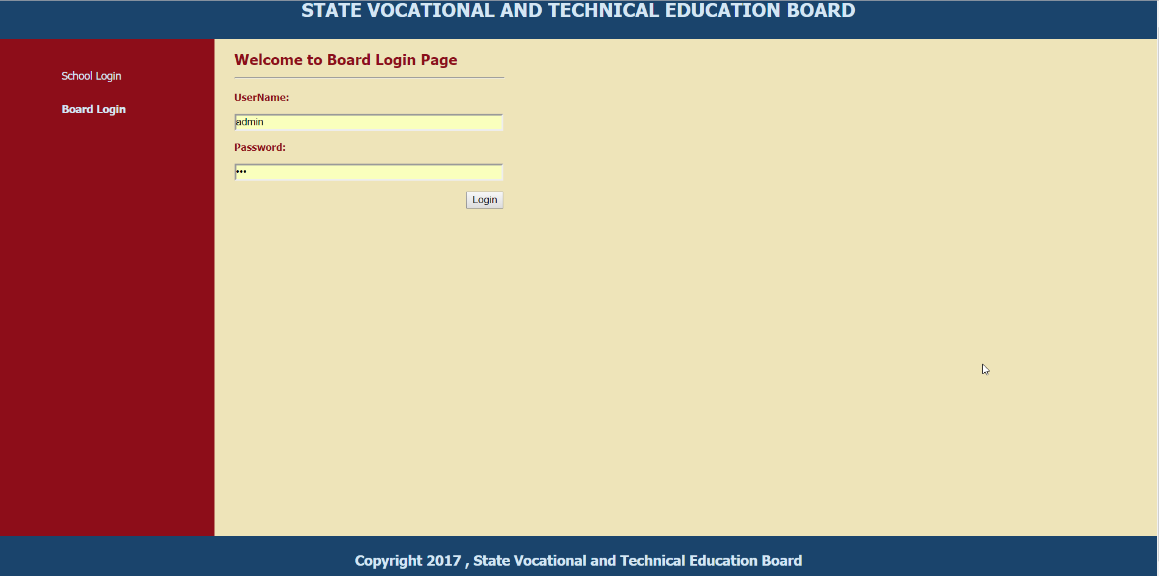*A diagram showing the board login page for state vocational and technical education system*

The diagram above shows the login form for the board administrator. The administrator provides their username and password and click the login button which submits the form. The system then authenticates the username and password using PHP scripting language.

Once the board administrator logs in to the system they can perform several functions:

Addition of a new school: This is done by filling in the form with details such as the school name, capacity, location details and any other details. They then submit the form for processing by PHP code. Several checks exist including, if the school name already exists, a message will be returned informing the user that they cannot submit the details because the school name already exists.

Addition of new users of the system: This is done by first selecting the school name for which to register the user, filling in the username, password, confirm password and any other details. The confirm password is to confirm if the password the user entered is one for which they had intended to enter. The details are then submitted for processing.

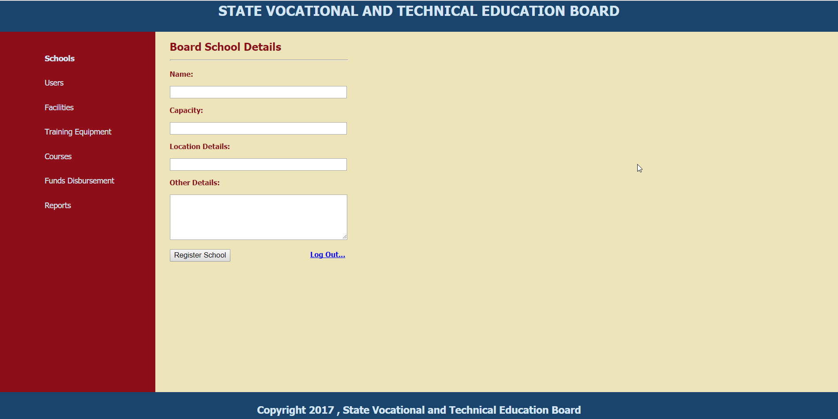*A diagram showing the board landing page for state vocational and technical education system*

Other functionalities for the administrators include: management of school facilities, management of school training equipment, management of school courses, funds disbursement and viewing of the various reports on data entered from the school users end.

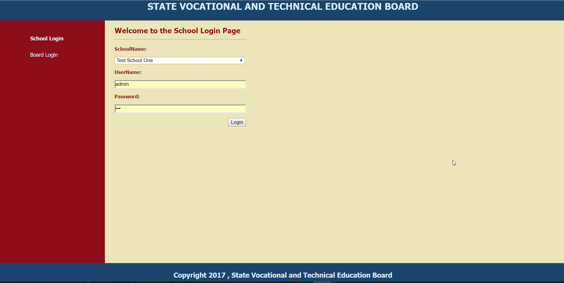*A diagram showing the school login page for state vocational and technical education system*

The diagram above shows the login form for the school administrator. The user selects the school name for which they are logging in. They then provide their username and password and click the login button which submits the form. The system then authenticates the username and password using PHP scripting language.

The school administrator functionalities include: entering student details, managing student attendance records, managing student discipline records, registering school exams and exam results, enter school extra curriculum activities, enter allocated school funds usage, enter school university affiliations and manage student leaving records.

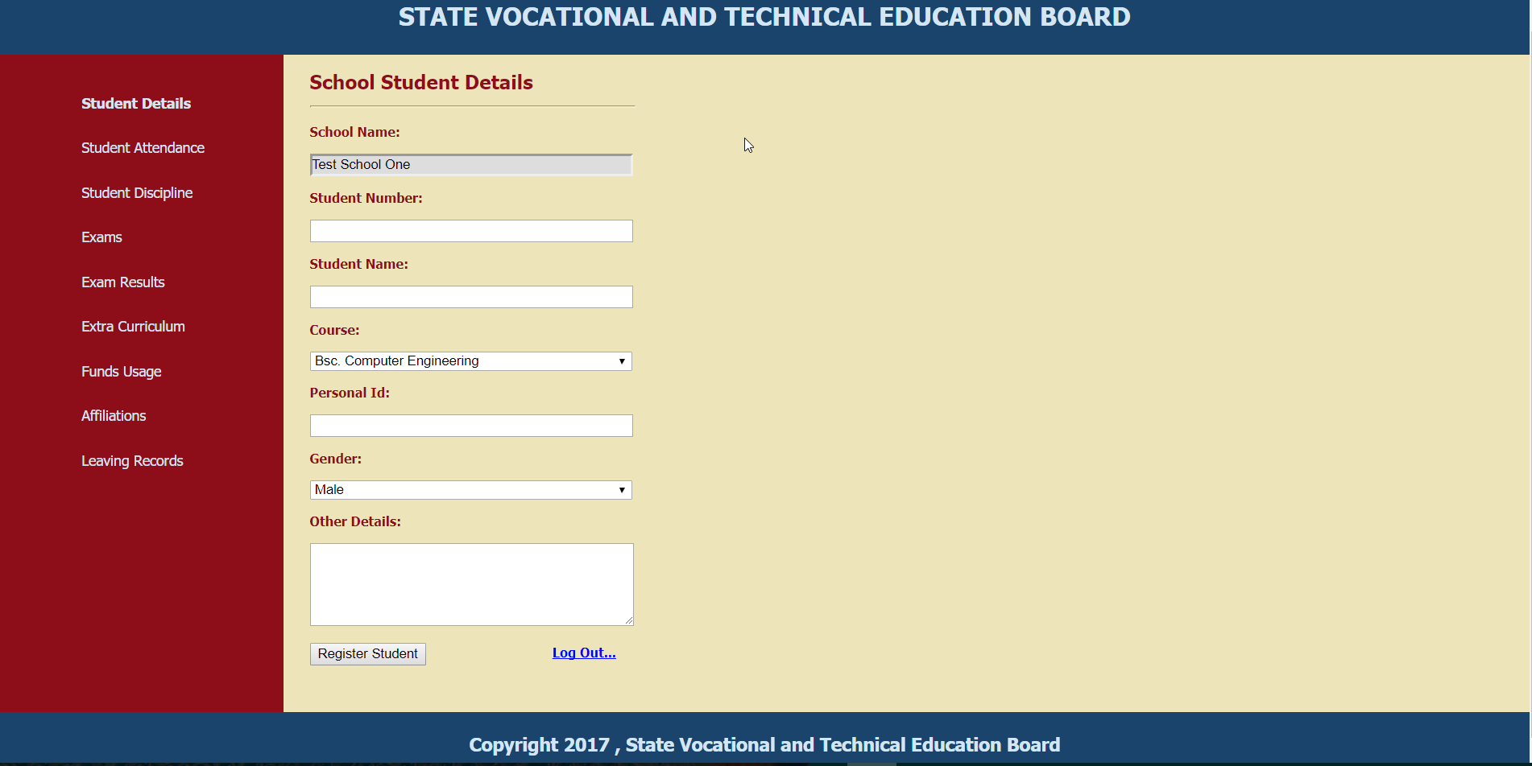*A diagram showing the school landing page for state vocational and technical education system*

# **CONCLUSIONS AND RECOMMENDATIONS**

State vocational and technical education board system is designed to solve the problem that exists in the board currently. The available system is manual making it difficult to access vital information about the schools on a timely manner. As such the board, cannot make their decision in regards to funds disbursement, school performance, school facilities among others on time.

The system is protected by use of login page for both the board and school users. Once the board user gains access to the system they can then perform several functions like adding schools, registering users, assigning school facilities, disbursing school funds, registering school courses, viewing reports among others. The school administrator is able to manage: student details, school attendance, student discipline, exams, exam results, extra curriculum information, funds usage among others.

The recommendation is that to enhance the security of the system, more user roles should be developed and a module for assigning user rights developed. This will enable assignment of specific user rights to different users.

# **REFERENCES**

1. Robin, N. (2013). Learning PHP, MySQL, JavaScript, and CSS, 2E. California: O’Reilly Media, Inc.

2. Randy, M. (2015). Practical UML: A Hands-On Introduction for Developers. [Online] embarcadero. Available at: https://edn.embarcadero.com/article/31863 [Accessed 07 Sep.2017]

3. Claire, C (2007). Beginning Database Design. New York City: Appress.

4. Smart Draw, (2015). UML Diagram. [online] Available at: https://www.smartdraw.com/uml-diagram/.

5. W3schools.com, (2001). JavaScript Tutorial. [Online] Available at: https://www.w3schools.com/Js/.

# **APPENDIX**

The following are sample questions were asked to the different stake holders including the state education and technical board employees, schools’ administrators and students. Sample answer is provided after each question.

1. What challenges are you facing with the current manual system?

Answer: The current manual system is not that reliable, slow and entirely depends on individuals for information to pass from one end to another.

1. What challenges should the system solve?

Answer: The new system should ensure that data is authentic, readily available and in a format on which the end user can comprehend easily.

1. What do you do manually that you would like to automate?

Answer: Exam results processing and ranking by the schools is currently manual and hence has a lot of errors in them. Changing the same is not easy.

1. How long does it take before you get a report from the schools?

Answer: It takes more than a week in to get reports from a specific school upon request.

1. How long does it take before you get a school fund disbursement notification from the board? Answer: : It takes more than a week in order for a school to know if their funds have been disbursed.
2. Are there instances where you are asked to produce data in regards to student enrollment?

Answer: Yes

1. Who will be using the automated system?

Answer: The system should be used by the state board employees and the various people to consolidate the data and make it available.

1. What should these people have access to?

The board should be able to manage high level schools’ information while the school administrators should be able to manage their individual school data.

1. What are training considerations for developers and users?

Answer: The users should have at least basic computer knowledge and the system developers should be able to train the users on the functionalities of the system.

1. What are the specific bottlenecks to getting at information?

Answer: Data is not readily available when it is required.

1. How much historical information is required?

Answer: The system should start off with the current data.

1. How do you currently store data?

Answer: Currently information is stored in physical files.

1. Are there any disadvantages in the method stated in number 12 Above?

Answer: Information look up is slow and requires some amount of time to retrieve.

1. Do you have information in regards to the training equipment in every school?

Answer: No

1. Any other comments or suggestions?

Answer: The system should be user friendly and intuitive to the users. This will enable users have a positive attitude towards the system even before they start using it. The advantage is that users will be able to understand the system in a speedy way.